Here is the tutorial of the handsim project:
- Environment Setup
  - Software Installation
- Set up the Vuzix hmd:
1. In the attached folder, double click the “VR_Manager_3.1.zip”, uncompressed this and install the VR_Manager_Installer.exe.
2. Double click the “Vuzix_SDK_3.1.1.zip”, then read the read me file. Install the “Vuzix_Eyewear_SDK-3.1.1.exe” first, then install the “AR_Ext_Setup_1.0.exe”.

3.The SDK installer creates the following two directories:
C:\IWEARSDK - SDK installation directory
C:\IWEARSDK\docs - SDK documentation directory
4. Build Instructions:
Debug builds are designed to run in windowed mode to ease debugging, while release builds run in full screen.
Add the following folder paths to your include directories:
<Vuzix SDK Path>\inc ------> <Platform SDK Path>\include
<Vuzix SDK Path>\lib ------> <Platform SDK Path>\lib

- Set up the cybergloves:
- Install VirtualHand SDK from the attached files: “VirtualHandSDKSetupV2_10_0.exe”
- Install VirtualHand for Motion Builder in the attached files:
” VH_for_MB_7_5_ext2_setup.exe”
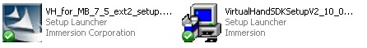

- From the Start Menu select Authorize.
- Copy the Site Code and send an email to support@cyberglovesystems.com with it asking that you would like a Site Key. (this should take one or two days)
- Authorize the software when you get the Site Key.
- Use the programmer's guide to get set up.

Note: All the SDK file has been included into an independent folder, so except installing the software, nothing more should be worried about.

  - Hardware Setup
There are three different devices we need to set up before running the code.
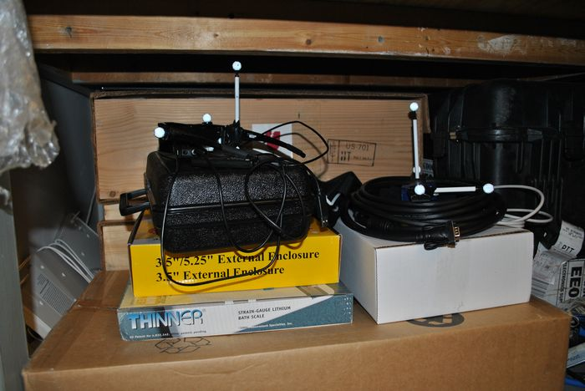
Cyberglove
HMD

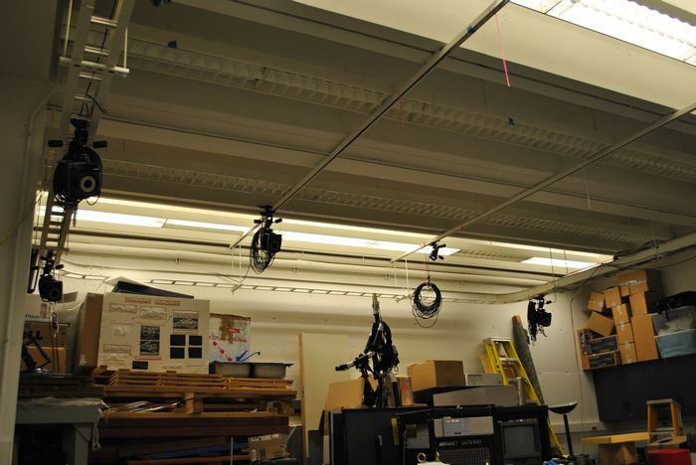
Mocap System
All the devices we need:

USB extension cabal
Arm markers sets

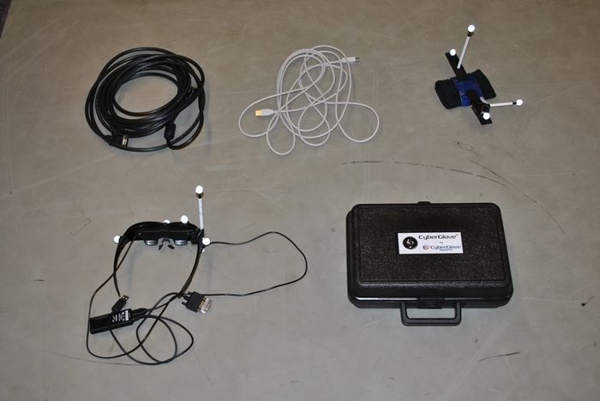
HMD glassed with markers
VGA extension cabal
Cyberglove

    - HMD
First: Put the HMD on the chair and in center of the mocap area.
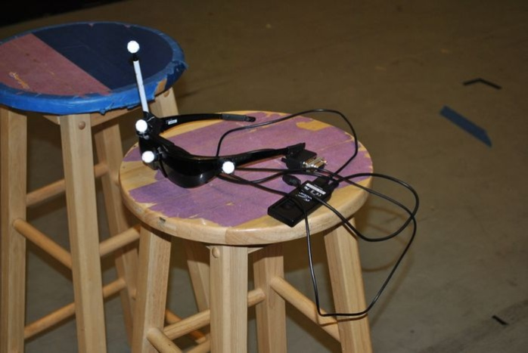

Second: connect the usb extension line and the VGA extension cable to the HMD.
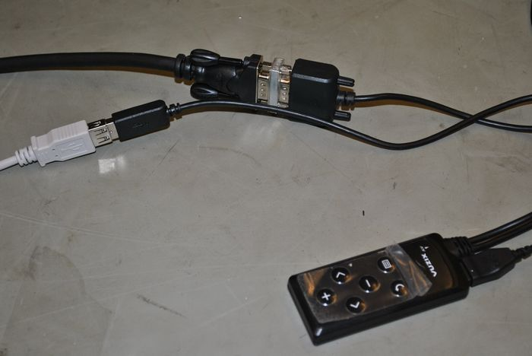

Third: Connecting the cable and line to the desktop.
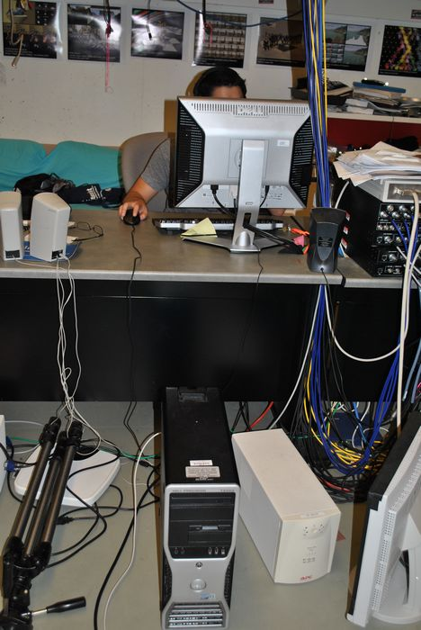

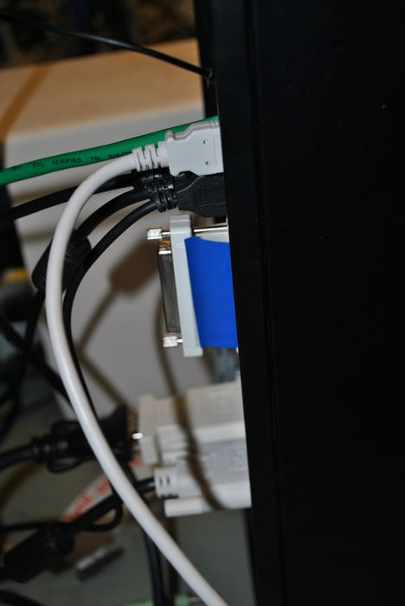
Connect to the right slot
    - Cyberglove
First: Put the cuff on another chair.
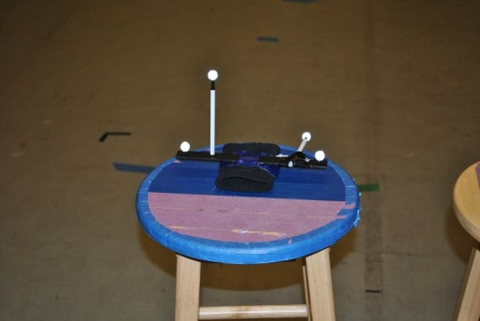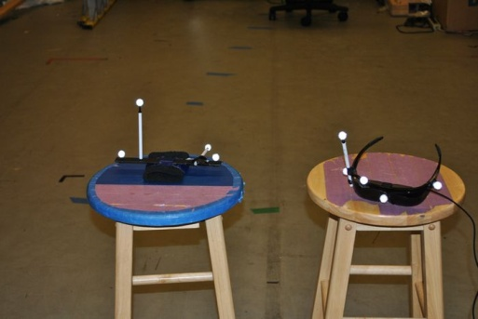

Second: Open the cyberglove box.
Cyberglove Sensor cable
Nylon glove inserts and Tracker accessory kit
Cyberglove data glove

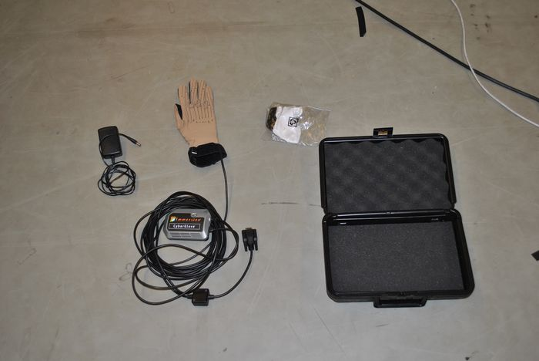
Interface module
Serial conversion box with power converter
AC/DC power supply

Then put the glove on the chair, too
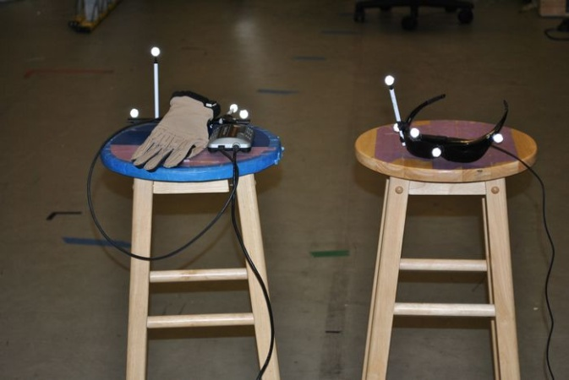

Third: connect the power convert to the desktop
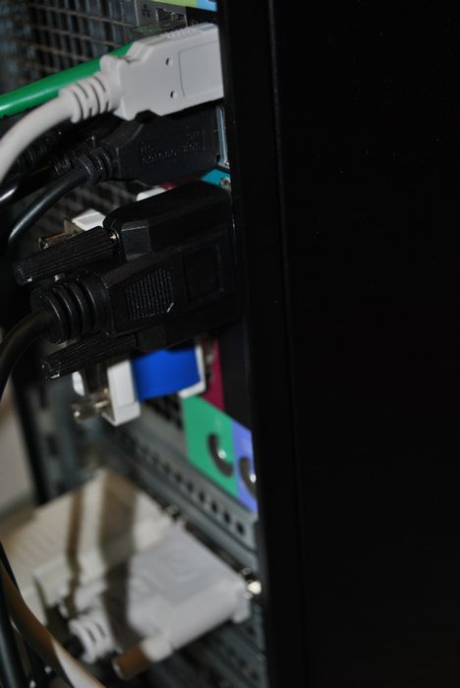
Fourth: connect the power supply
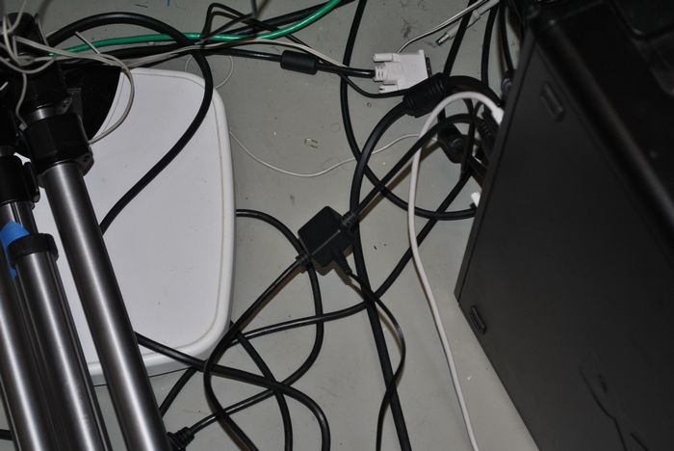

Fifth: connect the power supply to the plug-base.
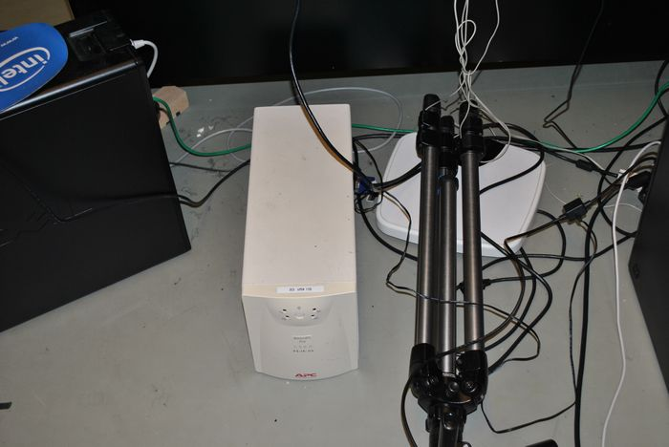
Finally: turn on the cybergleve
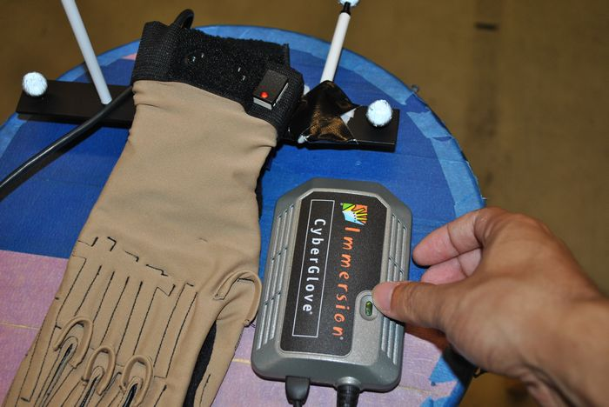

    - Mocap
Find the desktop which controls the mocap system and follow the instruction of the attached file.
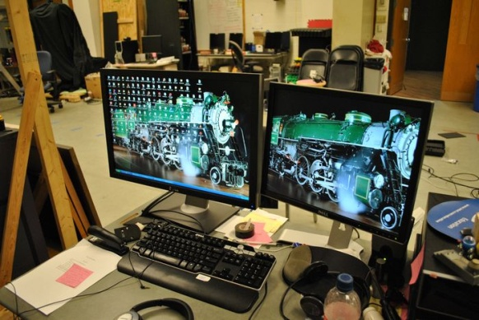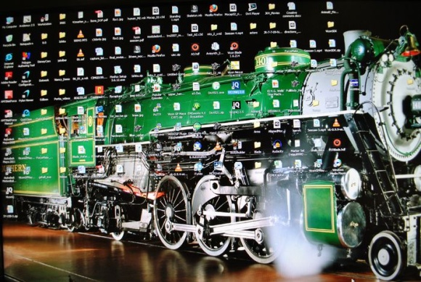

- Code implementation
2.1 CCyberglove
CCyberglove is the class used to connect the cybergolve hardware, to get all the 23 dof’s rotation data and used into our own hand model.
2.1.1 Parameters
vhtIOConn *gloveDict; | Virtual hand connection class
vhtCyberGlove *glove; | Virtual hand glove data glass
std::vector<double> g_d_rotate_array; | 23 rotation array

2.1.2 Methods
int connect(); | Connect to the cyberglove hardware
void updateRotation(); | Refresh the 23 dof rotation every frame
std::vector<double> getRotationArray(); | Get the rotation array from the 23 dof

2.2 CHMD
2.2.1 Parameters
float m_EyeSeparation; | Intraocular Distance: aka, Distance between left and right cameras.
float m_FocalLength; | Screen projection plane: aka, focal length(distance to front of virtual screen).
GLint m_screenWidth, m_screenHeight; | Screen width and height, same with the PC screen
HANDLE m_StereoHandle; | Handle to connect to the HMD stereo mode
bool m_StereoEnabled; | Flag to switch the Stereo mode

2.2.2 Methods
int connect(); | Function to connect the HMD
void SetViewingFrustum( int Eye , GLfloat fovy, GLfloat nearZ, GLfloat farZ, GLfloat aspect); | Set the frustum based on view mode and other parameters to set up the view
void prerenderSetting(int Eye); | Set which eye to render
void SetStereoViewport(int Eye); | Set view port based on the mode
void toggleStereoMono(); | Change between the Mono and Stereo Mode
void increaseEyeSeparation();  void decreaseEyeSeparation();  void increaseFocalLength();  void decreaseFocalLengthn(); | Change the Separation and the Focal length to set the 3D effect

2.3 CMocap
2.3.1 Parameters
char *hostname ; | The hostname to connect the server PC
int unlabMarkers; | Numbers of the markers in the VR world
ViconDataStreamSDK::CPP::Client rtmcClient; | real-time mocap client
_array<rtmcSubjectForDirectControl> m_rtmc_Subjects; | real-time mocap subjects
double cameraMatrix[16]; | Position and rotation Matrix of the camera
Void* m_rtmc_hThread; | thread handle for real-time mocap
bool m_b_rtmc_active; | mocap server connected
_array<CMeanFilterSE3> m_rtmc_filterT; | filter for each subject

2.3.2 Methods
bool rtmcConnect() | Function to connect the server
void rtmcDisconnect() | Function to disconnect the server
void rtmcUpdateData() | Update the position and rotation for each object
double* getCameraMatrix() | Return the camera matrix
SE3 getHandBasePose() | Return the hand model matrix

- Start Manager Software before run the project
There are two manager software you should start before running the code. One is the cyberglove manager and the other is the HMD manager. Also you need to change the resolution of the screen.

For the desktop in the lab, they are just in the start menu
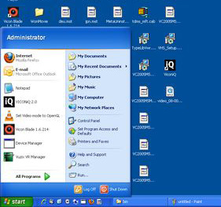
Cyberglove Manager
HMD Manager

If they are not in the start menu, you can also find them in the program menu

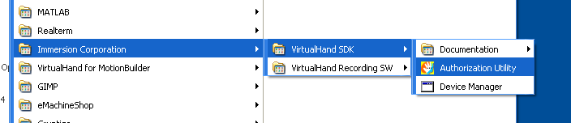

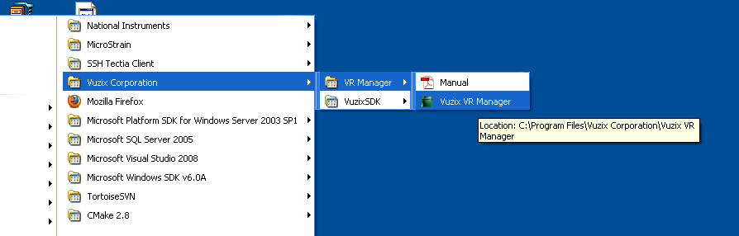

Besides, change the resolution of the screen. Once set up the HMD.
Right click the mouse and click the NVIDIA control panel.
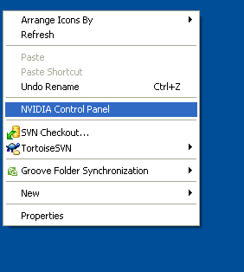
Then choose the “The screen on both displays” and “WR902 + Dell 2007FP”, and click Apply.
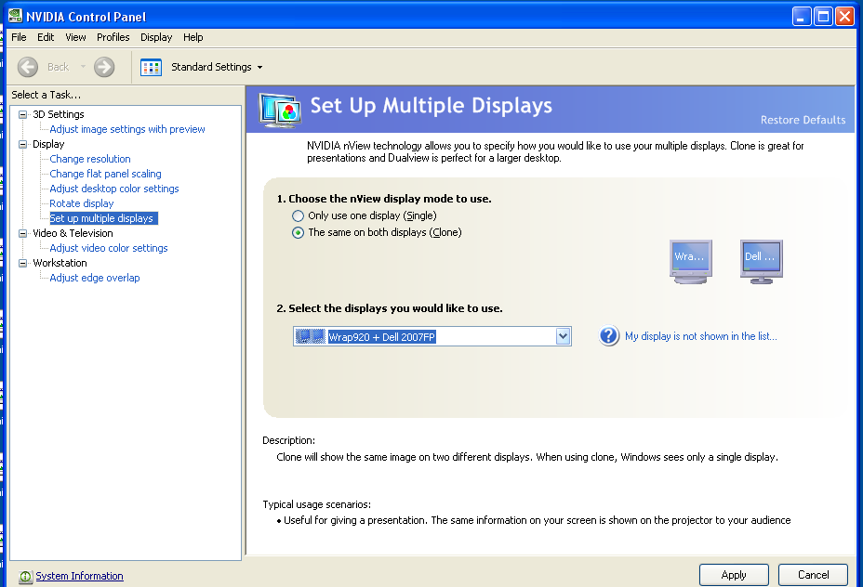

- Attached documents
There are several attached documents in the folder.
VR_Manager_3.1.zip | HMD manager
Vuzix_SDK_3.1.1.zip | HMD SDK
VirtualHandSDKSetupV2_10_0.exe | Cyberglove install software
VH_for_MB_7_5_ext2_setup.exe | Cyberglove motion builder
load_BMP_function.cpp | Function about how to load bmp texture
Junggon.cal | Junggon’s hand calibration data
Creating Your Own Objects.docx | Tutorial about how to set up the mocap
calibration guide-v4-4.pdf | File about how to calibrate people’s hand

